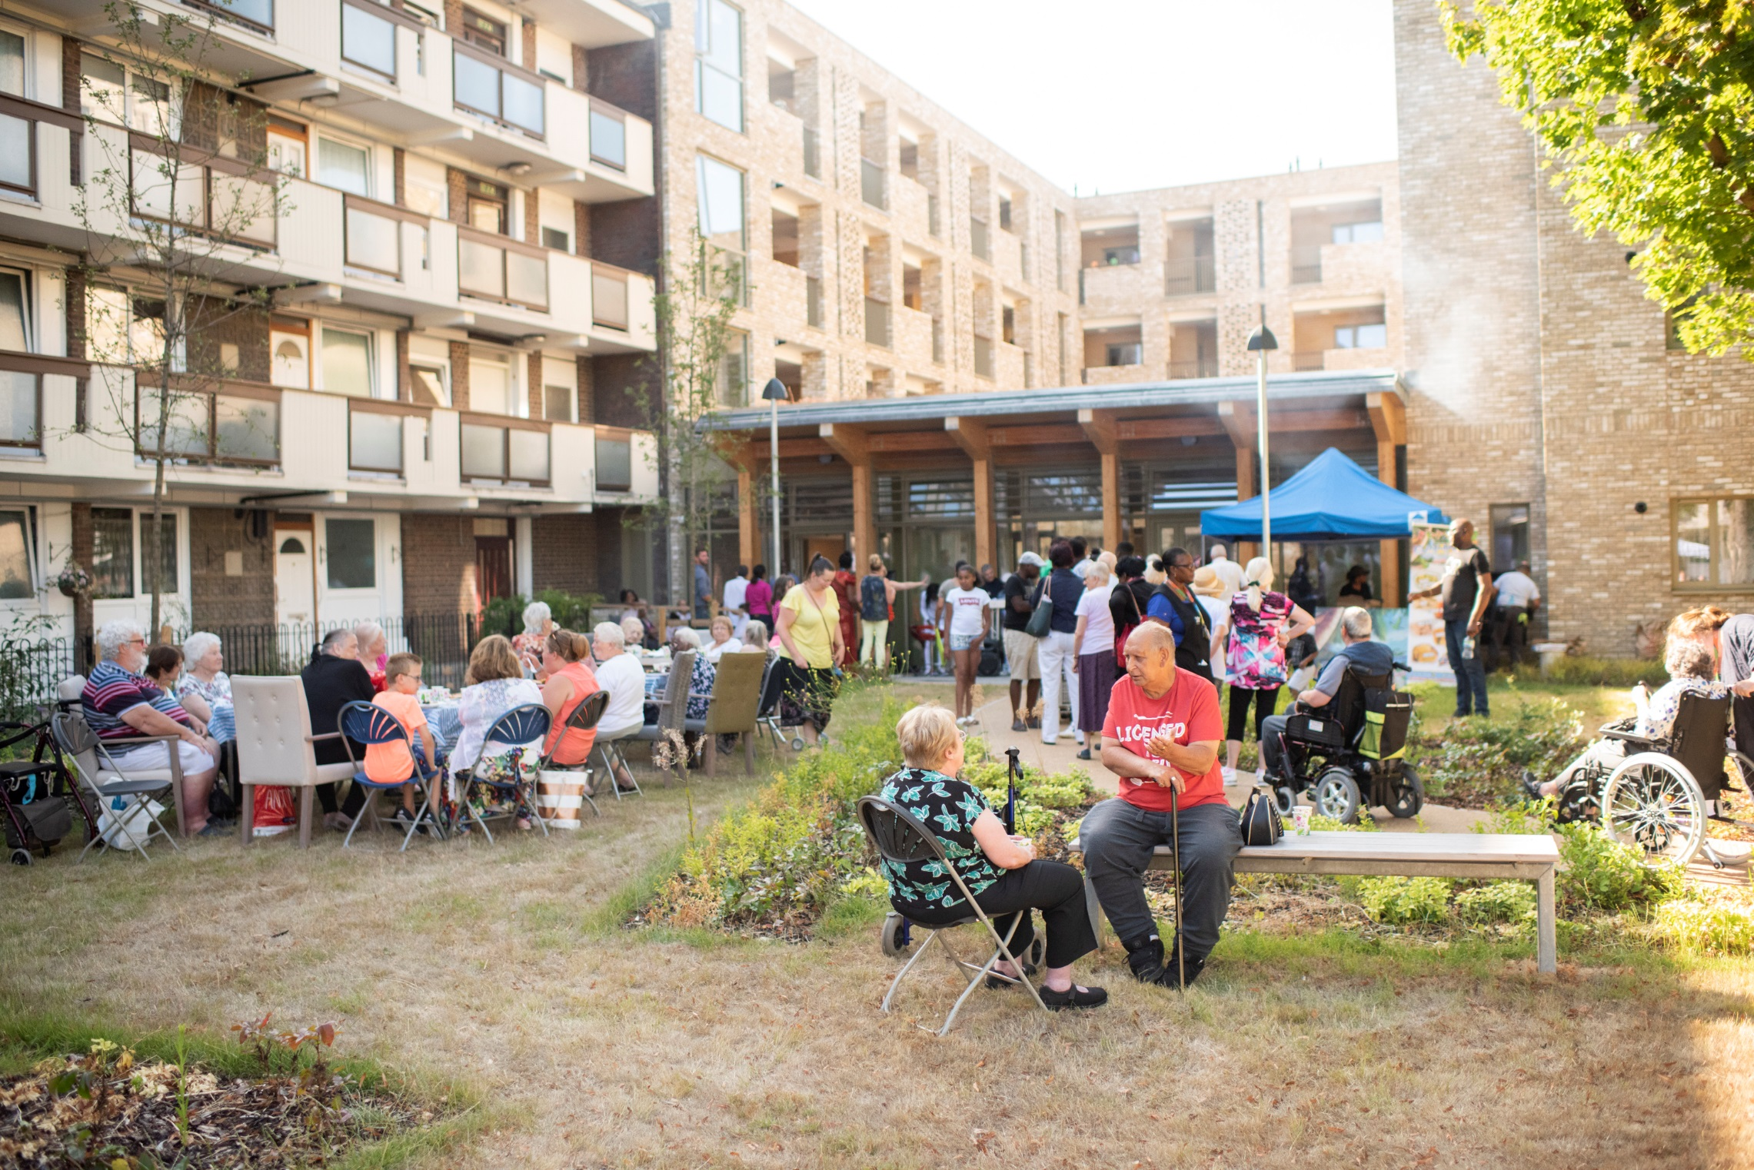
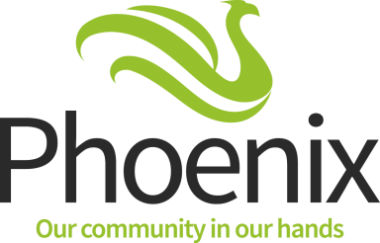
Chest
Application Form 2019-20
Community
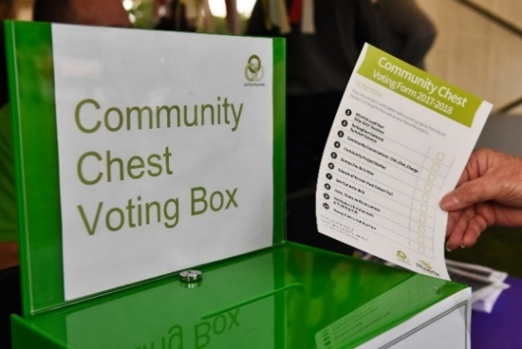
Thank you for your interest in applying for our Community Chest. We have tried to make the process of applying to the Grants Fund as simple as possible.
Completing this form
It is essential that, before you fill in this form, you make sure you have read through the Criteria for funding. This gives guidance on what should be included in your application.
This symbol indicates that the question will be scored by the Evaluation Panel. Information on how the scoring works can be found in the Criteria.

When you have completed this form you will need to provide us with supporting documents. A checklist of the documents required is included at the end of this application form.

You may want to ask another person to look over and check your application before you submit it.

Help to complete the form
We want to encourage local people/groups to apply to the Community Chest. If you would like some help or advice with your project idea or application, we’ll be having two drop-in sessions which will be run by Voluntary Action Lewisham from 10am – 4pm. These will take place on:

Thursday 7 February at Goldsmith Community Centre, Castillion Road, London SE6 1QD
or
Friday 8 February at The Green Man, 355 Bromley Road, London SE6 2RP

If you have any questions please get in touch by calling Freephone 0800 028 5700 and ask for the Community Chest Project Team or email cchest@phoenixch.org.uk

Also, if you have any communication needs (such as Braille, large print or translation) please contact us.

Submitting your application
We prefer submissions by email to:
cchest@phoenixch.org.uk

Alternatively, you can complete and send by post to:

Community Chest, Phoenix Community Housing, The Green Man, 355 Bromley Road, London, SE6 2RP.

When will you know the outcome of your application?

If you are applying for a small grant

The small grants are up to £2,500 each. Funding decisions for these grants will be made by the Community Chest Evaluation Panel. You will be notified on 3 April 2019.

If you are applying for a large grant

Awarding of large grants is subject to a two stage process.

Stage 1 the Evaluation Panel will review submissions to the large grants fund. The application will be scored by the panel and the highest scoring will proceed to stage 2.

Stage 2 applicants will be invited to have a stall to promote their project at the Phoenix Festival on Saturday 11 May 2019 in Forster Park when Phoenix tenants will vote for their favourite projects to determine which will receive funding. If you are applying for a large grant, you will hear if you have been successful to go to stage 2 on
29 March 2019.

Deadline

All completed applications must be received by 12noon Thursday 28 February 2019.

Grant Application Form
 |  |  | Please read these notes
 | Which funding are you applying for?  Small Grant – up to £2,500  Large Grant - up to a maximum of £20,000 |  | See Criteria Page 3.
 | How much will your project cost?  £  What is the cost per Phoenix resident (use your totals from page 7) £ |  | The cost per resident is calculated by dividing the project cost by the number of people who will benefit.
1. What is the name of your group/project?
(Please write in below)

 | 2. When will your project start and finish (dd/mm/yyyy)  Start: Finish:  Where will it take place (Please write in below) |  | Please tell us where you will be delivering your project from.
 | 3. Which Phoenix funding priority area(s) will your project meet?  (Please tick all that apply and write below each one ticked how it will meet that priority. No more than 50 words)  Health & Lifestyle  Thriving Communities  Training & Employment |  | Information on the funding priority areas is included in the Criteria on Page 4.
 | 4. Tell us what you project will be doing  (Please write in below. No more than 150 words) |  | Please describe your project. By ‘project’ we mean the event or activities you plan to carry out using our grant. Be specific about what your project will be doing, how you will do it, what you will spend the grant on and how it meets the funding priorities.
 | 5. Tell us what difference your project will make to participants? (Include the specific outcomes you expect to achieve and how you will measure them)  (Please write in below. No more than 150 words) |  | Outcomes are what the changes are/what difference you expect your project to make to Phoenix residents during the period of your project funding.  You must set out clearly how you intend to monitor the project outcomes and what evidence you will provide to support this. See Criteria Page 5.
 | 6. What evidence do you have to show that Phoenix residents support your application/project (this will be crucial in deciding which applications are funded)  (Please write in below. No more than 150 words) |  | Please tell us how you know Phoenix tenants and residents support your application/project. See Criteria Page 3.  It is very important to demonstrate that you have consulted with residents about your project idea.
 | 7. How will you recruit Phoenix residents to take part in your project?  (Please write in below. No more than 150 words) |  | Explain how you will make sure Phoenix residents will know about your project and how to benefit from it. Marketing is crucial to recruiting residents into your project - see Criteria Page 5. A list of communications options which can be provided by Phoenix are listed on this page .
8. Tell us about your organisation’s experience of delivering similar projects.  (Please write in below. No more than 150 words) |  | Please tell us about other projects your group/ organisation has been involved with, giving examples of the outcomes you achieved.
9. Does your project involve working with children, young people under the age of 18 or vulnerable adults?

Yes No
10. If yes to question 9, can you confirm that your organisation meets the requirements set in the Phoenix Grants Criteria?  Yes No  If your organisation is registered with, or inspected by, bodies that ensure safeguarding arrangements (such as OFSTED or the Care Quality Commission) please give details below, including any reference numbers. |  | Please see Safeguarding in Criteria Page 6 for what we expect from you.  We may seek further information from any bodies you are registered with, or inspected by.
 | 11. Are there any partner organisations involved in delivering your project?  Yes No  If yes, please give details of their involvement and if they will be providing any funds for your project: |  | Please include details of any other partners or organisations who might help with your project and whether they will be providing any funds for your project.
12. Are you or any members of your organisation employed by Phoenix Community Housing, Phoenix Repairs Service, a Phoenix Contractor or as a Phoenix Consultant?

Yes No

If yes please give details here:

About your organisation

What type of organisation are you?
(Please tick all that apply)

Voluntary or Community Group
Charitable Company Limited by Guarantee
Registered charity (if yes state number):
Other – (please say what):
Address of your organisation
(Please give your main or registered address. This is the address to which we will send all
correspondence)
Grant Holder Name:
Address:
Postcode:
Contact Telephone number:
Email address:
Organisation website address (if you have one)

References

Please provide two references to support your application. They will be contacted if your application proceeds

Referee 1 | Referee 2
Name:  Email:  Telephone Number:  How do you know this person: | Name:  Email:  Telephone Number:  How do you know this person:

Grant Expenditure Sheet

Project Name:

Please provide a breakdown of the project costs in the table below. You must ensure costs are eligible (see Page 6 of the criteria document).

You need to ensure you have enough funds in your budget to support marketing activity for your project.(e.g. leaflet design, printing, distribution). Recruitment of residents to your project is critical.

All equipment purchased from our grants remains the property of, and must be returned to, Phoenix Community Housing within 28 days of the end date of the project unless evidence can be provided of a future project will be delivered to Phoenix residents using the equipment purchased.

Type of expenditure | How this supports your project | Total cost  (Inc of VAT)
Example:  Leaflet design & print | Marketing materials for project recruitment | £500
Total

Phoenix will only award grant for expense that is eligible and is supported by a receipt. If you submit a grant claim without the correct supporting information it will be not be processed.

Phoenix residents who will benefit from your project

Please give details below of the Phoenix residents you think will benefit from your project.

Number
Children actively involved in the project 0-11 years
Young people actively involved in the project 12-24 years
Adults actively involved in the project 25 - 64 years +
People actively involved in the project 65 years +
Total Number

At the end of your project, you will be asked to complete another copy of this form with the actual numbers of participants in your project.

This means you must keep records of who takes part which include:

• name
• house number
• postcode

This information must be submitted to Phoenix to validate that project participants are Phoenix residents. The Community Chest funding is for Phoenix residents as defined in the Criteria document page 2.

We process this personal information to enable us carry out research, administering housing and property grants and maintaining our accounts.

If your application is successful we will agree an information Sharing Agreement with you which sets out how each of us will share and use this information in line with the Data Protection Act.

Summary of your application

Please provide a summary of your application, based on your answers for particular questions within the application. This will be scored by the Community Chest Evaluation Panel.
Project Name:
How much will your project cost? £ Cost per Phoenix Resident £
Maximum
10 points for each question
Tell us how your project will meet the funding priority areas
(Please give a summary from Q3, page 1, maximum 60 words)

Tell us what your project will be doing
(Please give a summary from Q4, page 2, maximum 60 words)

Tell us what outcomes you expect to achieve from your project and how you will monitor and provide evidence of how these will be achieved
(Please give a summary from Q5, page 2, maximum 60 words)

Tell us how Phoenix residents support your application/project
(Please give a summary from Q6, page 3, maximum 30 words)

How will you recruit Phoenix residents to take part in your project
(Please give a summary from Q7, page 3, maximum 30 words)

Total Points

Checklist of Supporting Documents

Please tick all that apply below

Supplied Not
Applicable

Completed Application Form

Constitution, Terms of Reference or governing document

Last Audited Accounts

Public Liability insurance

Health & Safety policy

Equal opportunities policy

Risk assessment(s)

Evidence of CRB/DBS checks

Evidence of support for your project from Phoenix residents

Safeguarding Policy or completed adoption form for Phoenix Safeguarding policy

Data Protection Policy

To be completed by the person who will be the grant holder
I certify that I have read and understood the Criteria document. The information provided in this application and accompanying documents are, to the best of my knowledge, true.

Please tick here to say you have read and agree

Name:

Date:
(dd/mm/yyyy)

Ensure you keep a copy of this application and supporting documents for your own reference.

