Community
Chest
Criteria 2020-21

Criteria
Funding will be made on the basis that project participants must live in the Phoenix area. We will expect that priority will be given to Phoenix tenants and leaseholders followed by people who live in the Phoenix area only. Projects must provide participant’s details for verification to the Community Chest manager to include: name, house number and postcode.

Help with completing your application form
Before completing your application, you must check that your organisation/project is eligible for funding.

We want to encourage local groups to apply to the Community Chest. If you would like some help or advice with your project idea or application, we’ll be having three drop-in sessions run by Voluntary Action Lewisham from 10am – 4pm. These will take place on:

11 February at Goldsmith Community Centre, Castillion Road, London SE6 1QD
or
13 February at Bellingham Leisure Centre, London SE6 3BT
or
14 February at The Green Man, 355 Bromley Road, London SE6 2RP

If you have any questions please get in touch by calling Freephone 0800 028 5700 and ask for the Community Chest Project Team or email cchest@phoenixch.org.uk

What we won’t fund
While we are keen to support a wide range of activities that contribute to thriving communities, we recognise that we can’t do it all. Therefore, in order to ensure that we continue to fund projects that complement our core activities we will not be able to fund any of the following: -

- previous Community Chest projects that have either not delivered or provided evidence of their project outcomes
- salaries for posts which are not dedicated to deliver your stated Community Chest funded outcomes or direct services that deliver these
- fundraising or income generating posts, activities or events
- the grant cannot be used to employ an external person or organisation to produce the project’s final report
- projects that do not benefit Phoenix tenants/leaseholders or their families
- feasibility studies
- activities promoting a particular religious or political belief, improvements to places of worship or buildings owned by religious bodies
- projects involving improvements to public roads or adopted highways
- any project which is the responsibility of a statutory body
- individuals or individual benefit e.g. mobile phones, laptops etc.
- existing projects or those that have already taken place
- travel/transport costs outside the scope of the project
- academic research
- incomplete applications

Resident support for your project
You will need to show us evidence of how you have decided that there is a need for your project and how Phoenix residents support your application. Some examples of the types of evidence you might provide are:
- organising a meeting that anyone interested in your project can come to
- carrying out a survey of people who use your service or those who might use it
- keeping a waiting list of people who want to get involved in your activities or use your service
- finding out if there is a lack of your type of project or activities in the Phoenix area and whether people would use it if it was available
- researching about the people who might benefit from your project, which may include statistics. Here is statistical information for the Phoenix areas which you may find useful: www.phoenixch.org.uk/community-needs-information
- finding out if your project supports the Phoenix funding priority areas
- evaluating previous projects or seeking feedback on a pilot project.

We have a Community Links event which all Phoenix residents are invited to attend. This is an opportunity for you to come along to meet our residents and discuss your project idea with them. This will take place on: Wednesday 19 February 2020, 5pm-7pm at the Green Man, 355 Bromley Road, London SE6 2RP

If you would like to attend you must contact the Community Links Project Manager either by email cchest@phoenixch.org.uk or telephone 0800 0285 700

Recruitment & Marketing to your project
Funding for the Community Chest comes from Phoenix tenants’ rent. It is very important that Community Chest projects benefit as many tenants and leaseholders as possible. Phoenix will not be responsible for recruiting residents to your project. Recruiting residents to be involved can be challenging, so you need to carefully consider how you will do this and ensure that you allow enough funds in your budget for marketing materials to support this. This may include:
- invitations/leaflets/poster design
- printing
- distribution e.g. postage, leaflet dropping

About the Grant Funding

Small Grants – a maximum of £2,500
There is £10,000 allocated for small grants. The Community Chest Evaluation Panel will award the grants from this fund. The decision of the Evaluation Panel will be final. Where appropriate, unsuccessful applicants may be signposted to other funding sources.

Large Grants – a maximum of £20,000
Awarding of grants is subject to a two-stage process:
Stage 1 the Evaluation Panel will review submissions to the Large Grants fund. The applications will be scored by the panel and only projects that have received the highest score will proceed to Stage 2.

Stage 2 applicants will be invited to have a stall to promote their project at the Phoenix Festival on Saturday 16 May 2020. The funding for large grants will be decided by Phoenix tenants voting for their favourite project(s) either at the Phoenix Festival, by post or voting via the Phoenix website.

All successful applicants will be required to attend the Setting Up Your Project Workshop and Safeguarding training at The Green Man on Thursday 21 May 2020, 10am – 2pm

Scoring of your application
Applications are reviewed and scored by our resident-led Evaluation Panel. The scoring definitions used by the panel are:

Score | Definition | Description
1-2 | Unacceptable /incomplete | Very little information provided and doesn’t answer the question
3-4 | Poor | Answers the question but not enough detail or information included
5-6 | Satisfactory | Answers the question in most respects but more information could have been given
7-10 | Good | A good answer in all respects supported with examples and/or additional information
10-15 | Very Good | Very clear and comprehensive answer in all respects. Including evidence to support statements or examples.

The Three Priorities for funding

Health & Lifestyle
There are inequalities in health, particularly affecting vulnerable groups and low-income households. Projects that help to reduce these inequalities will be considered under the following headings:
- help residents live healthier, longer and happier lives and encourage participation in cultural and exercise
- reduce health inequalities through supporting families with budgeting advice, healthy eating, cooking
- improve the quality of life for our ageing population
- provide activities which support and reduce isolation
- children and young people - provide positive activities, encourage achievement.

Thriving Communities
There are many ways for residents to get involved in their local community, as part of a club, community group, neighbourhood action group etc. Projects that contribute to the following aims will be supported:
- encourage local community participation and volunteering
- increase the confidence of local communities, supporting them to identify local solutions to local problems
- help all communities get on well together
- improve community cohesion, particularly between new and existing communities
- provide support for community participation and engagement
- provide facilities in new and existing communities, especially for young people
- increased engagement by children and families in fun, affordable and accessible activities
- enable community projects and groups to develop and become sustainable

Training & Employment
We particularly welcome applications from projects aimed at addressing unemployment, or which help to overcome the economic difficulties associated with poor education. Our priorities include projects that:
- support residents to become financially independent through employment
- encourage residents and the wider Phoenix community to take up training opportunities to enable them to enhance and improve personal skill, confidence and employment capabilities
- increase access and support to digital inclusion opportunities developing basic online skills to enable access to employment opportunities, benefits, Phoenix online services and a reduction in social and digital isolation
- support aspiring residents into social enterprise and self-employment
- improved life skills, confidence, qualifications and employment capability for 16 – 25 year olds

Project Outcomes

It is really important that you clearly describe how you will measure the outcomes from your project. You will need to provide evidence of these and tell us in your application how you will do this. Your funding maybe withdrawn if you are unable to provide sufficient evidence of how you will collect, monitor and measure your outcomes. Any future funding will also be dependent on your previous project’s delivery success.

Outcomes are what changes, difference or benefits your project makes to the Phoenix residents who take part in it, therefore they should be achievable and realistic. It is better to focus on a few key outcomes that clearly set out what you are trying to achieve, for example, ways of measuring these could include:

- Questionnaires: A questionnaire at the start of the project and one at the end to evaluate what has changed during the project
- Case studies: at the beginning and at the end of the project.

Examples of evaluation tools are available on our website at: www.phoenixch.org.uk/toolkit

For further information on measuring impact you might find the following websites useful:
Voluntary Action Lewisham (VAL): www.valewisham.org.uk/show-your-impact
The Arts Council: www.artscouncil.org.uk/selfevaluation

Final Report

If your application is successful you will be required to submit a report after the project has finished. This must include what outcomes have been achieved from the project, how they were measured, the number of participants and an overview of how the grant funding was spent. The report must be submitted no later than 4 months after the project has been completed.

Support from Phoenix

We will acknowledge and publicise your grant award and the nature of your project or event on our website (www.phoenixch.org.uk), on our twitter feeds (@phoenixtogether / @greenmanhub), in our quarterly resident newsletter (Phoenix Flyer) and in a press release to local media.

If accurate and approved content is provided to us in good time we can promote events or opportunities to our residents and broader community via:
  - our website
  - twitter accounts
  - press releases
  - the media wall at The Green Man
  - Phoenix Flyer

We are also happy to display leaflets in the Green Man reception area and may be able to arrange displays of posters (created and supplied by grant recipient) on our estate noticeboards.

Safeguarding
If your project involves working with children, young people under 18 or vulnerable adults you must also provide evidence of the following:
- safeguarding policy. We will require all projects who do not have a safeguarding policy to adopt the Phoenix policy. This can be found at: www.phoenixch.org.uk/sites/default/files/documents/CS%20Safeguarding%20Policy%20FINAL%20V3%20Sept%202019.pdf
- DBS checks (formerly CRB)
- complete a rigorous recruitment and selection process for staff and volunteers who work with children, young people or vulnerable adults, including checking criminal records and taking up references
- follow statutory or best practice guidance on appropriate ratios of staff or volunteers to children, young people or vulnerable adults
- provide child protection and health and safety training or guidance for staff and volunteers
- carry out a risk assessment
- secure extra insurance cover, if appropriate.

Grant Expenditure
- a breakdown of your costs and grant expenditure will be required
- to ensure Value for Money, we may ask you to provide more than one quote for goods and services
- any equipment costs included within the application must be supported with a detailed explanation of use and how necessary it is for delivery of the project.
- the grant cannot be used to employ an external person or organisation to produce the project’s final report
- the grant could be required to be repaid if:
  - false information has been supplied
  - the money has not been spent on delivering the project agreed in the Service Level Agreement
  - the final report is not submitted
  - the money has not been spent in the agreed time limit of the project

All equipment purchased from our grant fund remains the property of Phoenix Community Housing. This must be returned within 28 days of the end date of the project unless evidence can be provided that a future project will be delivered to Phoenix residents using the equipment purchased.

Supporting Documents
If your project is successful you must provide copies of relevant supporting documents which will include:
- Constitution, Terms of Reference, Articles of Association or governing document
- Last Audited accounts for groups who have them
- Public Liability insurance
- Policies
  - Health & Safety
  - Equal opportunities
  - Safeguarding
  - Data protection
- Risk assessment(s)
- Evidence of DBS (Disclosure & Barring Service, formerly CRB) checks (for projects working or volunteering with children or vulnerable adults)

Projects unable to provide policies listed may be able to adopt Phoenix Community Housing policies.

Community Links
Your bid is more likely to be supported if the project takes place in the Phoenix area. Most Phoenix properties are in the SE6 and BR1 postcodes. There are a very small number of properties in the BR2 and BR3 postcode areas. This map illustrates the Phoenix area.
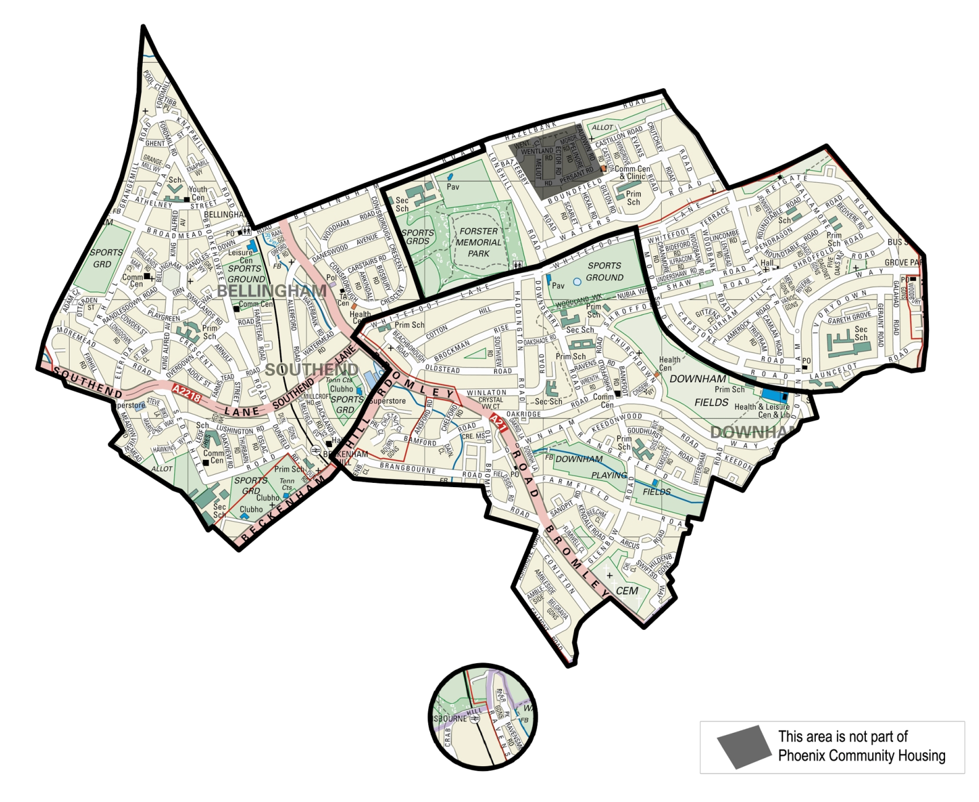
The Phoenix Area

