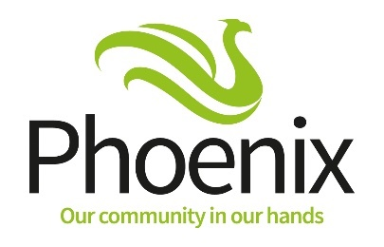
Community Chest
Supporting Lewisham Borough of Culture

Application Form 2021

Completing this form

It is essential that, before you fill in this form, you make sure you have read through the Criteria for funding. This gives guidance on what should be included in your application. Please note that projects must be completed by 31 December 2022. More information about the Lewisham Borough of Culture can be found on their website: https://www.iamlewisham.uk/

This symbol indicates that the question will be scored by the Evaluation Panel. Information on how the scoring works can be found in the Criteria page 3. The highest scoring are Questions 3 and 4.

A list of the supporting documents that you will be expected to provide if you are successful are listed in the Criteria page 6.

Help to apply to the Lewisham Borough of Culture Community Chest
We want local people/groups to apply. If you would like some help or advice with your project idea or application we are offering the following support:

An initial telephone conversation:
Tuesday 28, Wednesday 29, Thursday 30 September: anytime between 4.30pm – 6pm

45-minute consultation (appointment only):
Tuesday 5 October Time: 10am – 4pm: Green Man, 355 Bromley Road, London SE6 2RP
Wednesday 6 October Time: 4pm – 7pm: Zoom

To book a slot contact Lillian Brown lillian@lillianbrownconsulting.co.uk or tel: 07824 366761

If you have any questions please get in touch by calling Freephone 0800 0285 700 and ask for the Community Chest Project Team or email cchest@phoenixch.org.uk

Also, if you have any communication needs (such as Braille, large print or translation) please contact us.

Submitting your application
We prefer submissions by email to: cchest@phoenixch.org.uk Alternatively you can send it by post to Community Chest, Phoenix Community Housing, The Green Man, 355 Bromley Road, London SE6 2RP.

All completed applications must be received by no later than
12 noon Friday 15 October 2021

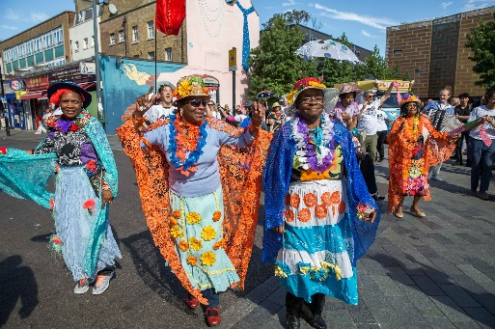
When will you know the outcome of your application?
Funding decisions for the grants will be made by the Community Chest Evaluation Panel. You will be notified on 11 November 2021. If you are successful, you will be required to attend our Setting-up Your Project Workshop on Thursday 18 November 10-2pm via Microsoft Teams

Grant Application Form
 |  | Guidance Notes
What is the cost of your project? | Total number of Phoenix residents who will benefit from this project? | Please insert the Total Number from the Phoenix residents who will benefit from your project form on Page 6
What is the name of your project/group?
(Please write below)

When will your project start and finish (dd/mm/yyyy)  Start Finish  Where will it take place (Please write below)  Please confirm you can deliver your project in a Covid-19 safe way |  | Please tell us where you will be delivering your project from.
1 Which Borough of Culture funding theme(s) will your project meet?  (Please tick all that apply)  We will protect this place we love  Write in no more than 50 words how you will meet this theme  We are strengthened by our diversity  Write in no more than 50 words how you will meet this theme  We will be happy here  Write in no more than 50 words how you will meet this theme |  | Information on the funding priority areas is included in the Criteria on Page 2.
2 Tell us what your project will be doing  (Please write below in no more than 150 words) |  | Please describe your project. By ‘project’ we mean the event or activities you plan to carry out using our grant. Be specific about what your project will be doing, how you will do it, what you will spend the grant on and how it meets the funding themes.  Maximum 5 marks
3 What are the specific outcomes of your project and how will they make a difference to the Phoenix residents taking part?  (Please write below in no more than 150 words) |  | Outcomes are what the changes are/what difference you expect your project to make to Phoenix residents during the period of your project funding. See Criteria pages 3-4.  Maximum 15 marks  Important  This is a highest scoring Question
4 Complete the 4 bullet points below to tell us what methods you will use to measure the outcomes/differences your project has made to the Phoenix residents who take part e.g. questionnaires, satisfaction surveys, case studies |  | You must set out clearly how you intend to monitor the outcomes/differences the project will make and what evidence or methods you will be using to support this. See Criteria Pages 3-4.  Maximum 20 marks  Important:  This is a highest scoring question
5 How will you recruit Phoenix residents to take part in your project?  (Please write below in no more than 150 words) |  | Explain how you will make sure Phoenix residents will know about your project and how to benefit from it. Marketing is crucial to recruiting residents into your project - see Criteria Page 4. Phoenix will not be responsible for recruiting residents. A list of communication-options which can be provided by Phoenix and Lewisham Borough of Culture are listed in Criteria Page 4.  Maximum 10 marks

6 Tell us about your experience of delivering similar projects and the outcomes you have achieved  (Please write below in no more than 150 words) | Please tell us about other projects your group/ organisation has been involved with, giving examples of the outcomes you achieved.
7 Are there any partner organisations involved in delivering your project?  Yes No  If yes, please give details of their involvement and if they will be providing any funds for your project: | Please include details of any other partners or organisations who might help with your project and whether they will be providing any funds for your project.
8 Are you or any members of your organisation employed by Phoenix Community Housing or subsidiaries, as a Phoenix Contractor or as a Phoenix Consultant?  Yes No  If yes, please give details here: | Phoenix subsidiary companies are:  Phoenix Repairs Service,  Home Makers

Phoenix residents who will benefit from your project

Please give details below of the Phoenix residents you think will benefit from your project.

 | Number
Children actively involved in the project 0-11 years
Young people actively involved in the project 12-24 years
Adults actively involved in the project 25 - 64 years +
People actively involved in the project 65 years +
Total Number | 0

If your project involves working with children, young people under the age of 18 or vulnerable adults you will be required to provide:

- Your safeguarding policy
- Written confirmation that any person involved in delivering your project has a DBS check number

If your organisation is registered with, or inspected by, bodies that ensure safeguarding arrangements (such as OFSTED or the Care Quality Commission) please give details below, including reference numbers:

Further information can be found on Page 5 of the Criteria.

Summary of your application scored by Evaluation Panel

Please provide a summary of your application, based on your answers for particular questions within the application. This will be scored by the Community Chest Evaluation Panel.

Project Name:
Cost of Project: Total Number of Residents Benefitting:
Tick the funding theme(s) your project meets

We will protect this place we love Strengthened by our diversity We are happy here

 | Points
Tell us what your project will be doing  (Please give a summary from Q2, page 3, maximum 60 words) | Maximum: 5
What are the specific outcomes of your project and how will they make a difference to the Phoenix residents taking part?  (Please give a summary from Q3, page 3, maximum 60 words) | Maximum: 15
Tell us how you will measure the differences your project has made to the Phoenix residents who take part e.g. questionnaires, satisfaction surveys, case studies  (Please insert the 4 bullet points from Q4 page 4) | Maximum: 20
How will you recruit Phoenix residents to take part in your project?  (Please give a summary from Q5, page 4) | Maximum: 10
Total Points

Grant Expenditure Sheet

Project Name:

Please provide a breakdown of the project costs in the table below. If you are partnering with another organisation, only include the expenditure for the Phoenix funding. You must ensure costs are eligible (see Page 5 of the criteria document).

You need to ensure you have enough funds in your budget to support marketing activity for your project (e.g. leaflet design, printing, distribution). Recruitment of residents to your project is critical.

All equipment purchased from our grants remains the property of, and must be returned to, Phoenix Community Housing within 28 days of the end date of the project unless evidence can be provided of a future project will be delivered to Phoenix residents using the equipment purchased.

Type of expenditure | How this supports your project | Total cost  (Inc of VAT)
Example:  Leaflet design & print | Marketing materials for project recruitment | £500
Total |  | £0.00

Phoenix will only award grant for expense that is eligible and is supported by a receipt. If you submit a grant claim without the correct supporting information, it will be not be processed.

About your organisation

What type of organisation are you?
(Please tick all that apply)

Voluntary or Community Group
Charitable Company Limited by Guarantee
Registered Charity (if yes state number):
Other (please say what):
Address of your organisation
(Please give your main or registered address. This is the address to which we will send all correspondence)
Grant Holder name:
Address:
Postcode:
Contact Telephone number:
Email address:
Organisation website address (if you have one)

References
Please provide two references to support your application. They will be contacted if your application proceeds
Referee 1 | Referee 2
Name:  Email:  Telephone Number:  How do you know this person: | Name:  Email:  Telephone Number:  How do you know this person:

To be completed by the person who will be the grant holder
I certify that I have read and understood the Criteria document. The information provided in this application is, to the best of my knowledge, true.

Please tick here to say you have read and agree

Name: Date: Click or tap to enter a date.

Ensure you keep a copy of this application for your own reference

